# Opening – Cropping – Saving (Save As) New Folder

Step 1: Open the file named: **Crop1.jpg** (in folder: Beginner Images)

Step 2: Go to toolbar on left and choose **rectangular marquee tool**.

Step 3: Drag with mouse over image, select area to crop.

Step 4: Go to **IMAGE** (above program on browser) – select crop from dropdown menu to make the crop you have chosen using marquee tool.

Step 5: Go to **FILE** Then **SAVE AS** (will open a dialogue box) select **New folder** (use your name) then save your cropped image to that new folder.

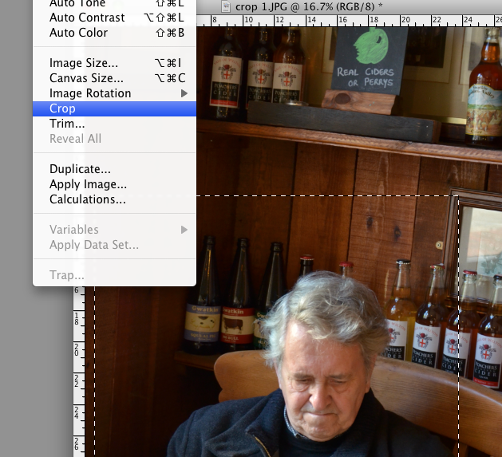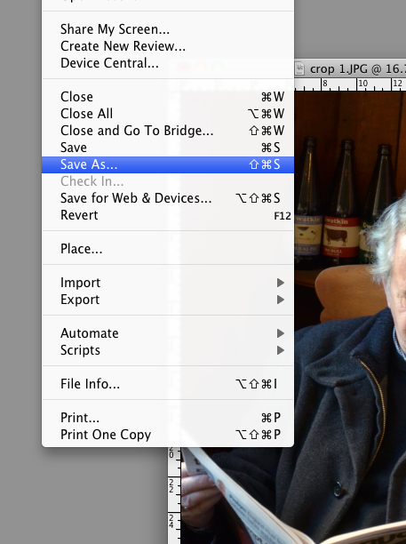

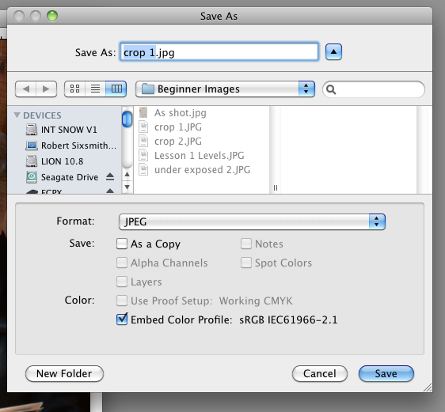

Once you have opened a new folder with your name, save all your work to this folder **KEEP ON DEKTOP; COPY FROM DESKTOP TO YOUR MEMORY STICK**