Week 5: Level 1 and 2 (LAYER STYLES)

Objectives
- You will open 5 images from the session WEEK 5 folder and bring them into Photoshop Workspace. You are going to create a poster with a knocked back black and white image for the background then open and resize 4 London images onto that background and apply different LAYER STYLES to enhance your design. You will use STROKE; DROP SHADOW, OUTER GLOW AND COLOUR OVERLAY.

- You will set guides (Guide Lines) within your template in order to create accurate placement of images to give a tidy and precise design.

- Using EDIT- TRANSFORM- you can choose the rotate, skew or warp tools to experiment and produce an individual layout.

Outcomes
1. You will learn about how to manipulate LAYER STYLES to bring an element of attractive design to your images and make them presentable for posters, adverts or just make interesting sets for your own enjoyment.
STEP 1
- Open images from WEEK 5: Folder named LONDON.

- Open all the images at once by selecting them all using FILE – OPEN IN BRIDGE – COMPUTER – (browse for your USB stick and open the Week 5 folder and the LONDON FOLDER containing the images for this week’s session.) Press SHIFT to highlight all 5 images then double click on last one to open all 5 images at once.

- NEXT: GO TO: Window – Arrange – 6 up (see image below)

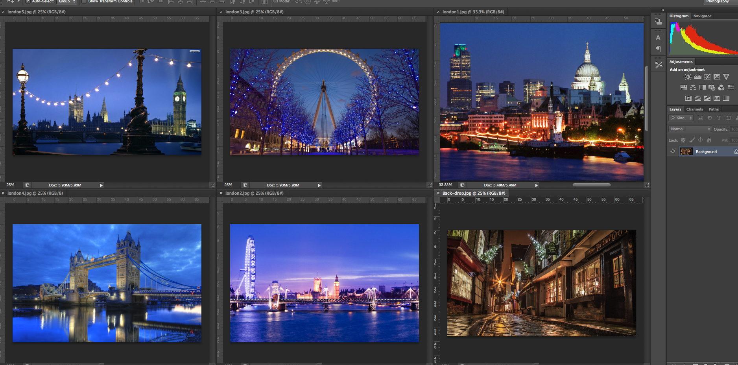
STEP 2:
Ensure that you have the tab called AUTO SELECT ticked at the top left of the Photoshop top menu section: This will make it easier when you click on any of the image layers so you know which layer you are working on.
Click on each image in turn and reduce the magnification in the small window to 25% (SHORTCUT TIP: press cmd – three times)
STEP 3:
Click on the top tab of image named:Back-drop.jpg and move it into the centre of your screen ready for editing: (see image below)
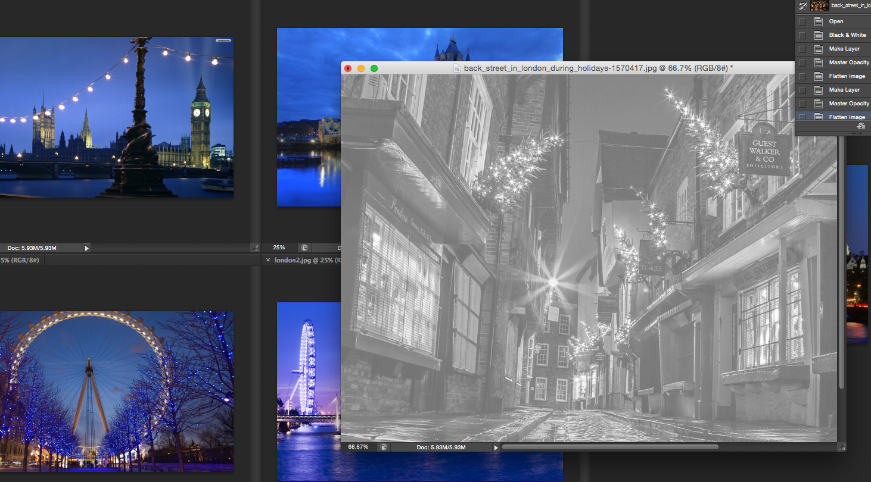
NEXT: We are going to convert the Back Drop Image into a Black and White image:
GO TO: IMAGE – ADJUST – BLACK AND WHITE.
NOW GO TO YOUR LAYERS PALLETE: (see image below) double click the padlock to allow editing and unlock the layer. Then reduce the opacity to 50% : Then go LAYER – FLATTEN IMAGE
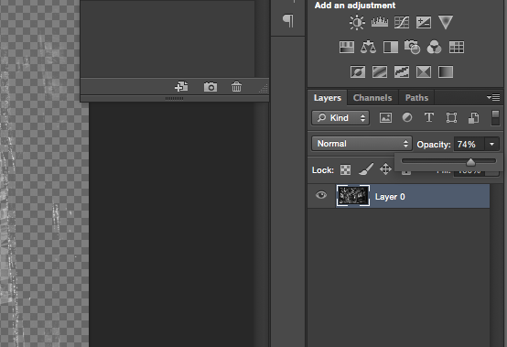
STEP 4:
You can enlarge the Back Drop Image by pressing cmd + and then enlarge the window using the bottom corner tab.
NOW: press your tool tip pointer (the top tool in your TOOLS BAR) on each image ready to copy and paste each image onto the back drop image.

STEP 5: Select first image by clicking onto it: PRESS: cmd A (this will select all the image with a crop marquee) then cmd C (Copy).
Next find your Black and White image (It will probably be behind the Photoshop main windows – just shrink the PS interface to a smaller window to reveal it).
NOW: click on the Back Drop image and press cmd V (Paste) This will drop that image over the Back Drop Image. Now go to: EDIT – TRANSFORM – SCALE and scale the image to fit as a smaller image on the Back Drop Image. Press Return/Enter to apply.
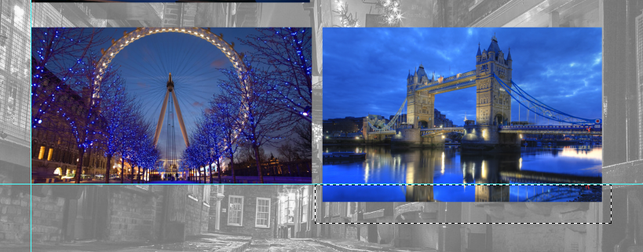
You can use the CROP TOOL to crop to size on any layer (see image above): just drag the crop marquee and press DELETE or BACK SPACE. This will crop the smaller image to suite
REPEAT ABOVE STEPS FOR ALL THE REMAINING IMAGES IN YOUR WORK SPACE. (See image below)
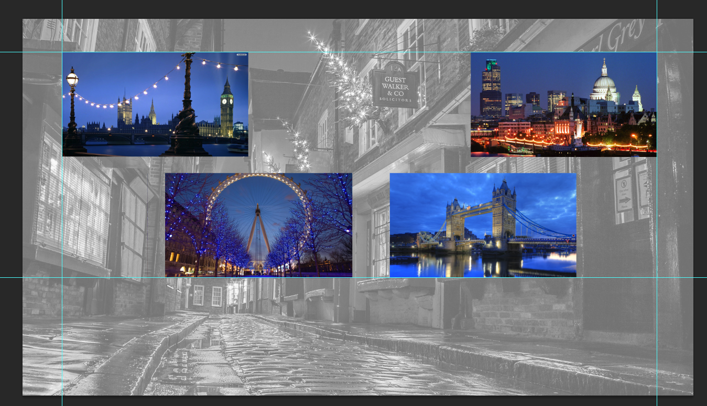
STEP 5: After using the EDIT – TRANSFORM –SCALE tools position your smaller images for an attractive and well-spaced design. You can use the GUIDES if required: Simply GO TO: View – New Guide.
This will open a dialogue box as below:
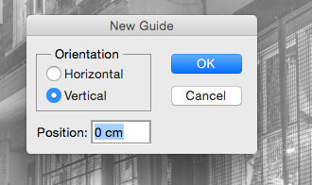
Choose either a Horizontal or Vertical guide. (This will place only one guide in your frame! To add guides repeat this step adding more guides)
The guides can then be moved to create equal sections for you to line up your images to. Just use your TOOL TIP (First tool on PS Tool bar).
YOU MAY NEED ONE TO ONE HELP HERE! Just call me for help!
STEP 6: You can now experiment with LAYER STYLES: Go to: LAYER – LAYER STYLES –
First pick up the STROKE style from the drop down menu.
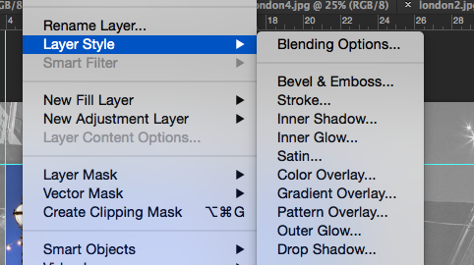
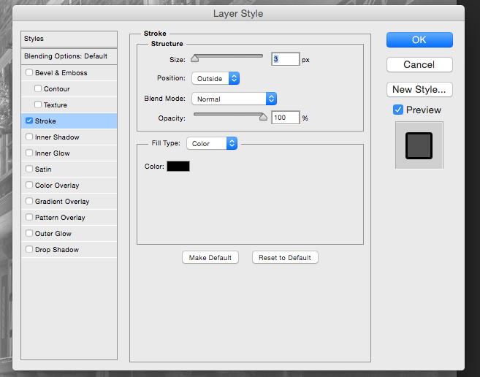
This will open a dialogue box with various options (experiment with these to produce a nice white or coloured border.)
NEXT: try the same procedure as above to pick up a different style: Try – Drop Shadow:
Then try Outer Glow and Coloured Overlay.
For more dramatic design effect, experiment with more EDIT – TRANSFORM – SKEW or even DISTORT to get some interesting looking designs as shown below:

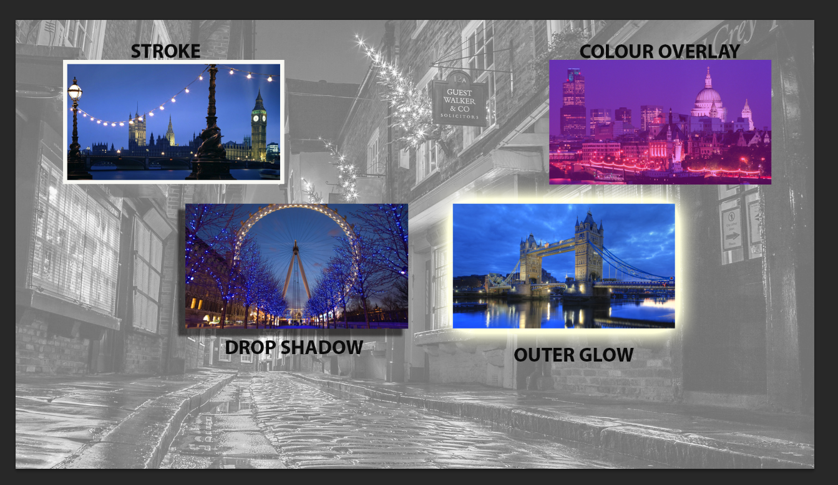
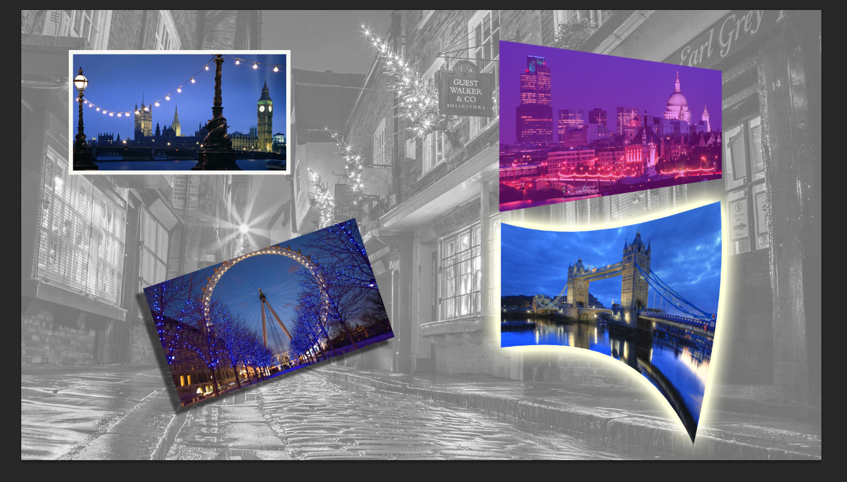

Please don’t hesitate to ask me for extra tuition or guidance … I am here to help!

