# Level 1: Image Correcting Objectives

1. Main objective: to open under and over exposed images from file named (Session Images) on the desktop/memory stick and using basic tools, correct for brightness, contrast, exposure, vibrancy and colour.
2. Apply various colour filters and sharpness to improve images.
3. You can open as many images as you like and experiment with the levels.
4. Save all your corrected images to a new folder on the desktop and name the folder with your name.

# Level 1: Outcomes

1.You will be able to adjust images for exposure, contrast, colour and vibrancy bringing under and over exposed images back to a level of acceptability.

2. You will have a good understanding of the LEVELS HISTOGRAM and be able to make your own adjustments and have a good understanding of the RGB mode corrections.

3. You will be able to correctly save the images you have worked on into a new folder with your name and save to the desktop.

4. You will be able to save a copy of this folder to your own memory stick.

5. You will be able to apply SHARPNESS to improve your corrected images.

**TASK 1**

Open the image named “under exposed2.jpg in folder called SESSION IMAGES – Under Exposed Images.

Go to toolbar at top of Photoshop Interface: GO: **Image – Adjust – brightness and contrast**:

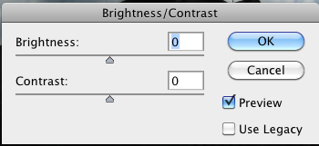

Move the sliders to adjust both. You will notice that this tool gives you very little range for this under exposed image. You will need to use a more useable tool to get the desired effect and correct this particular image. PUT THE SLIDERS BACK TO 0 or PRESS CANCEL.

**TASK 1 CONT:**

Now GO: **Image – Adjust – Levels.** This brings up the levels histogram.

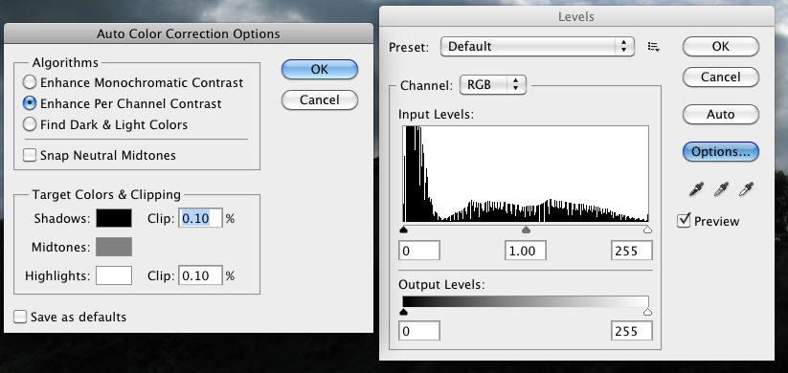

There are a number of procedures you can use from this toolbox. Experiment by first adjusting OUTPUT LEVELS. You will notice that there isn’t a lot of correction to be gained from just using this method. You will need to adjust levels for SHADOWS – MIDTONES – HIGHLIGHTS.

Experiment by moving the sliders on Input Levels. Now you can see that you have more control over shadows, mid tones and highlights.

TASK 2: OPTIONS

If you press Options on this dialogue box it will bring up a new toolbox: From here you can fine-tune the image correction method. (You will need tutor guidance for this).

Once the exposure is determined to your satisfaction press the OK box to implement your changes.

**TASK 3: FINE TUNING FOR COLOUR.**

**GO: Image- Adjust – Colour**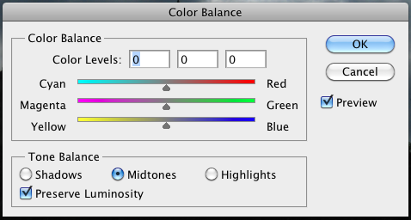

**TASK 4:**

Now that you have corrected this image for exposure, brightness, contrast and colour you can fine tune the image by adding VIBRANCE: Image – Adjust – Vibrance.

The vibrance tool and settings will allow you to give some depth to what is a flat resulting image.

The final tweek to improve this image would be to add UNSHARPE MASK: Filter – Adjust – Sharpen - Unsharpe mask.

SAVE YOUR RESULTING IMAGE TO A NEW FOLDER ON THE DESKTOP.

Open some more images from the UNDER EXPOSED and OVER EXPOSED SESSION IMAGES.

Experiment (Don’t forget to save your images back to your named folder.

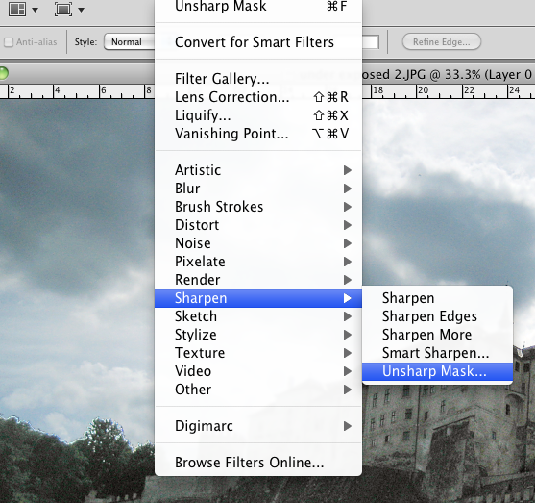

Using the above techniques you will be able to correct images that are under or over exposed and as a result have poor contrast and weak colours. You will also be able to use the techniques for over exposed images as long as the over exposure is not beyond +3 stops (aperture settings).

It is always worth noting that over exposed images with complete burnt out highlights are very, very difficult to bring back to normal.