# Level 2: (Advanced Curves) Objectives

1. Main objective: to open under and over exposed images from file named (Session Images) on the desktop/memory stick and using advanced CURVES, correct for brightness, contrast, exposure, vibrancy and colour.
2. Apply various colour filters and sharpness to improve images.
3. Use transform tool to correct perspective.
4. Use gradient tool to add a quick sky.
5. You can open as many images as you like and experiment with CURVES.
6. Save all your corrected images to a new folder on the desktop and name the folder with your name.

# Level 2: Outcomes

1.You will be able to adjust images for exposure, contrast, colour and vibrancy bringing under and over exposed images back to a level of acceptability.

2. You will have a good understanding of the CURVES TOOL and be able to make your own adjustments and have a good understanding of the RGB mode corrections.

3. You will be able to master the edit and transform perspective tool to correct converging verticals.

4. You will be able to alter HDR toning levels for this effect.

5. You will be able to correctly save the images you have worked on into a new folder with your name and save to the desktop.

6. You will be able to save a copy of this folder to your own memory stick.

7. You will be able to apply SHARPNESS to improve your corrected images.

**TASK 1**

Open the image named “Level2.jpg in folder called SESSION IMAGES – Under Exposed Images.

Go to toolbar at top of Photoshop Interface: GO: **Image – Adjust – Curves**:

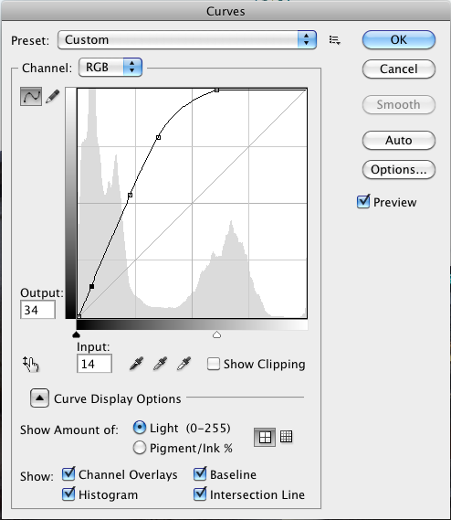

You will notice that there is a grey-scaled area on the vertical and horizontal axis, rather like a graph. There is a graph like plotting curve that you can experiment with to alter all RGB corrections.

RGB = All levels

R= red layer only B= Blue layer G = Green Layer: Experiment by choosing each layer and see what happens when you adjust these levels.

**TASK 1 CONT:**

Try using the auto button … see what the result is like. I think you will notice that this is ineffective for these under exposed images that are well out of range. You will need some tutor guidance to explain these settings.

**TASK 2: QUICK SKY**

Once you have the correct exposure finalised you will notice that the sky has become very white and rather dull. So … LET’S ADD A VERY QUICK SKY.

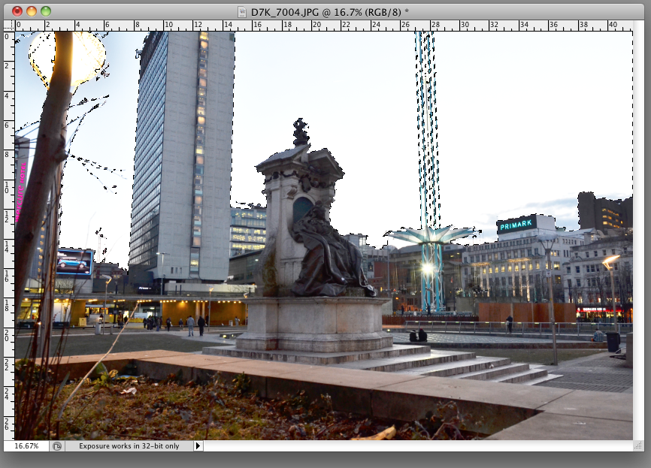

Quite often in the UK, weather and lighting conditions give us a lot of shadows in our images and unfortunately, a lot of rather dull white and grey skies. It can be a long-winded retouching job to cut and paste a new sky for every shot like this. One quick way to get a hint of blue sky is to use the **MAGIC WAND TOOL and GRADIENT TOOL.**

**TASK 3:**

Go to the tool bar and pick up the magic wand tool. Then go to the layers palette as shown and **UNLOCK THE LAYER as shown below:**

**Simply double click on the padlock icon:**

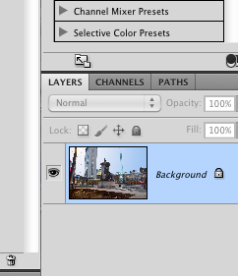 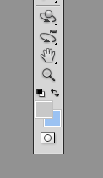

After you have double clicked the padlock icon it will allow certain adjustments to that background layer.

Next: go to the foreground and background colour setting found on the bottom of the tool bar. Double click on each and set the colours to a neutral grey or white and the other to a nice baby blue.

These settings will allow the gradient you are about to set move from light to dark.

NEXT: Select the gradient tool.

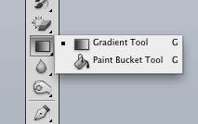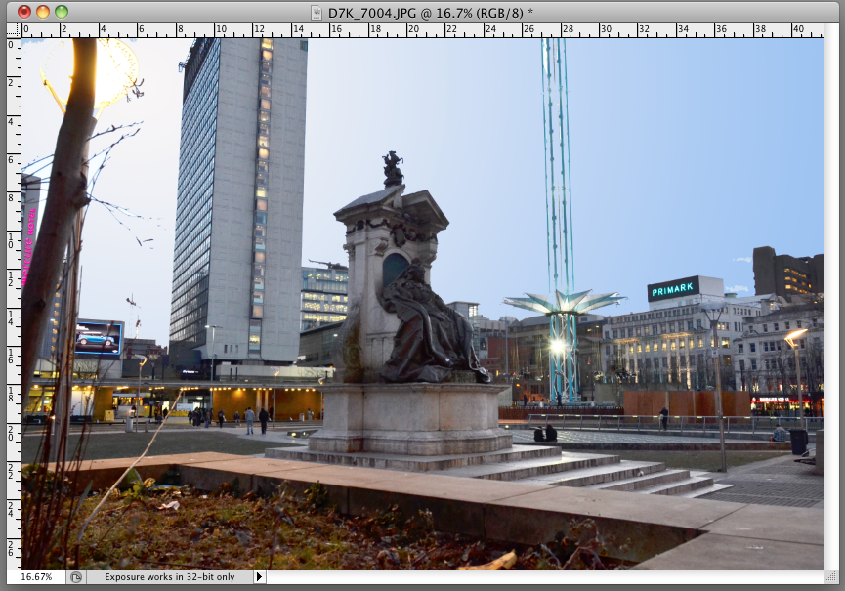

Moving the gradient tool to the image, hold down the mouse (you will notice a line appear) drag this line across your image and let go!

You will notice that the gradient of white to blue gives the appearance of a slight blue sky. NOW HOW QUICK WAS THAT?

Experiment with different angles of line and see which you like best.

**TASK 4: CORRECT THE PERSPECTIVE**

**GO: Edit- Transform – Perspective**

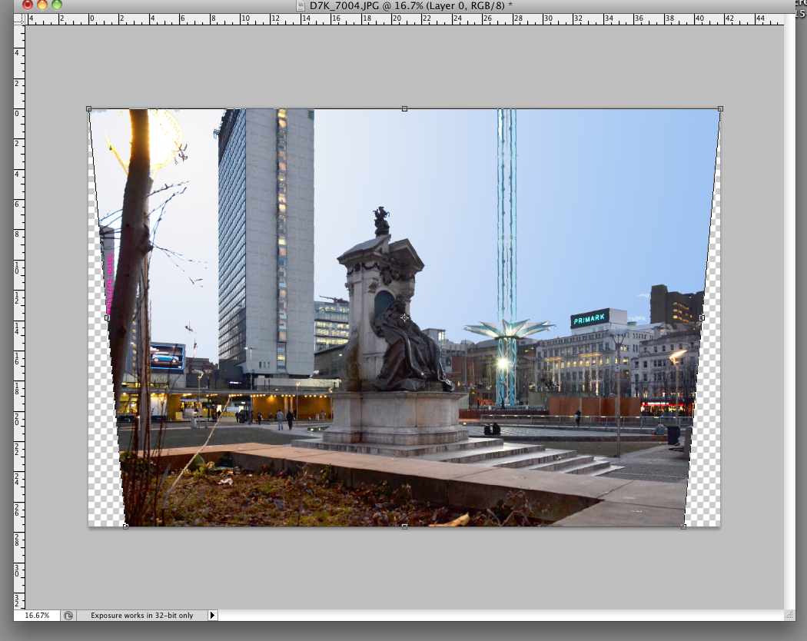

When you choose the perspective tool you will notice that a marquee type-cropping outline will surround your image. Choose the far left bottom anchor and push the image to correct the converged verticals. (Tutor Assistance may be required here)

Once you are happy with your selection don’t forget to OK this to apply the transformations.

**NOW: Choose the cropping tool** to finally crop closer to the image removing any grey areas as a result of perspective transformation.

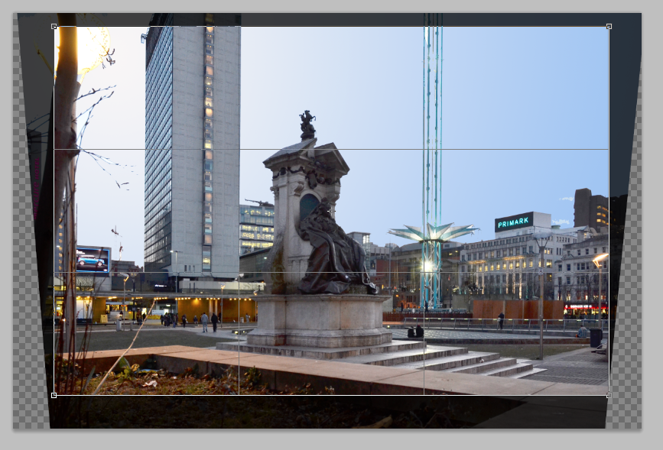

# HDR TONING (High Dynamic Range)

**TASK 5: Go: Image – Adjust – HDR Toning**

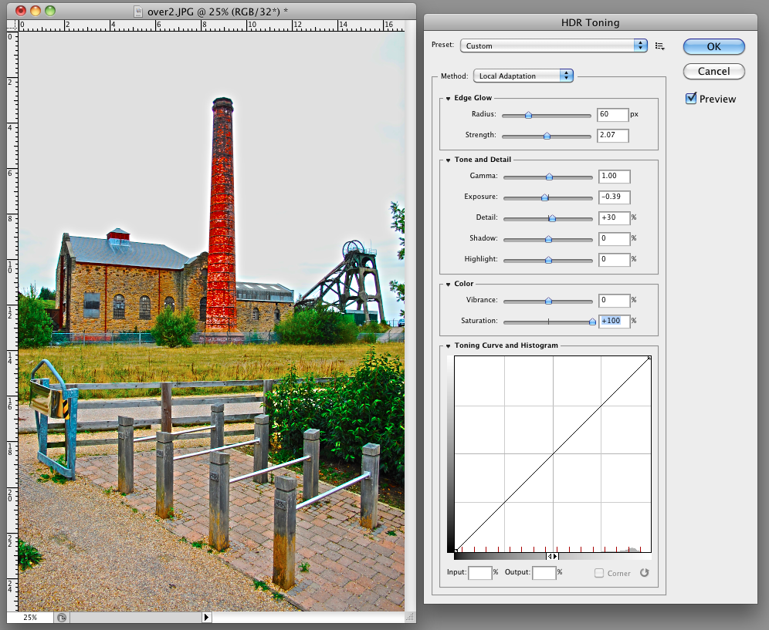

Whilst this is Photoshop’s simulation of HDR (High Dynamic Range) it does give rather convincing results.

Use the exposure, gamma, vibrancy and saturation sliders for your desired effect. Or you can use the drop down pre sets for some weird colour correcting fun!

Open up as many of the images as you have time for and experiment with all of the tools shown in your level 2 tasks.

Don’t forget to save all results in your folder.

Copy this folder to your memory stick and leave on desktop for my parousal.